Baseball Missions Project
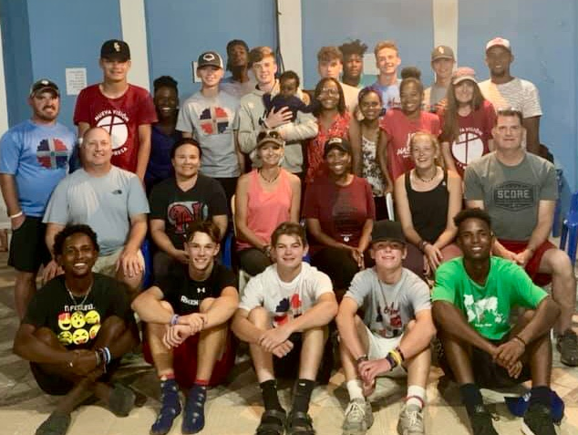
As some of you may know, last week the La Represa ministry team hosted 17 adults and youth for a week of serving alongside the baseball ministry. We are grateful for the way teams represent you the sponsors in the community! (Parents and children often ask if the visiting Americans know you.) Since you weren’t all here with us last week, here’s a rundown of what we did!

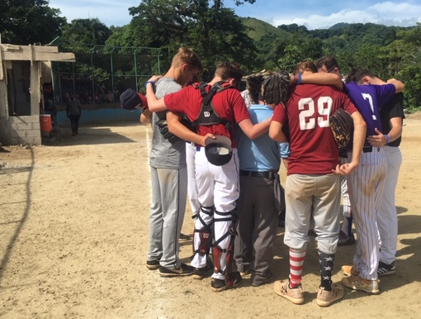
Sunday, the ten youth guys from the mission team got to see the baseball field in construction and play a game against the older boys in the baseball ministry. In the afternoon, we went to the church service where Buchanan students pastor Jason preached and the American youth sang for the church. That night, we celebrated two birthdays: an American who turned 16 and a Dominican who turned 15. It was a sweet night that represented an exciting day of watching two cultures come together.

Monday and Tuesday mornings, we helped with renovations at the baseball field, a dream that the community has had for years. Together with some baseball boys and other members of the community, we continued construction on the dugouts (we finished one, and the other will be done within a week) and helped with the renovation of the bleachers. The team also took it upon themselves to fix the pitcher’s mound and do some overall cleanup at the field. Tuesday morning, one of the youth was also able to teach a Bible study in the classroom of the boy her family sponsors. (Moments like these are my favorite!)

Monday afternoon, the team held a baseball clinic for 35 guys are part of the baseball ministry. A few team members shared their stories and biblical truth with the youth. Everyone involved was encouraged as they learned from one another and got to know each other more. It was also precious to see one of the team members teaching his sponsor children some of the basics of baseball.
The plan was the same for Tuesday, but we were rained out due to a lot of much-needed water! Some of the team played in the rain, and we had a shorter day.

Wednesday, we had a rest day at the river. Some team members hiked, and others stayed back to prepare food and play dominoes. In the afternoon, the youth guys got their hair cut and played baseball and basketball.

Thursday, we took a trip to the community of Los Asise, where the Re-Vision organization serves and got us connected. We had a clinic in the morning followed by two games. We were also able to leave many baseball supplies for the coaches and youth. Pastor Jason shared the gospel and three people decided to follow Christ, including one of the Americans on the trip!

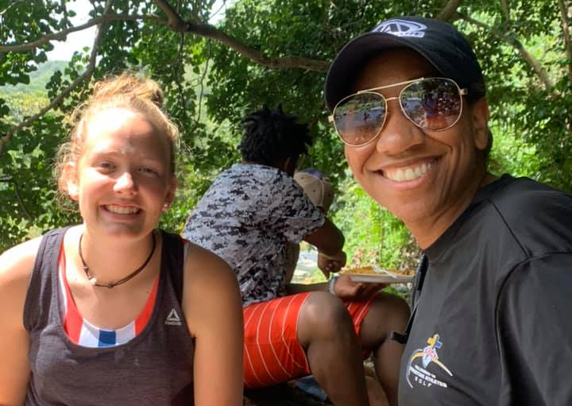
Friday started with the team members visiting families in their homes. In the afternoon, we played baseball and softball and admired the field improvements. The team also presented baseball equipment to the team in La Represa and the nearby community of Caobal. Pastor Jason shared the gospel again, and another American and two Dominicans came forward to accept Christ. After they prayed, 14 more expressed an interest in accepting Christ, all of which we are following up with and inviting the baseball ministry Bible study.

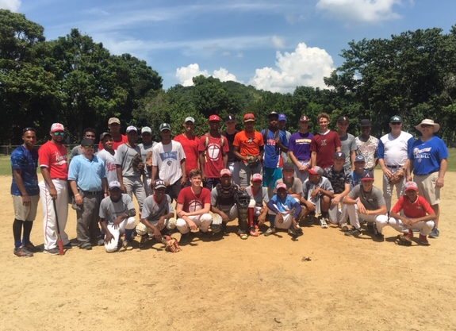
Friday night, we invited our Dominican family to dinner. After we ate, we reflected on the week and expressed our gratefulness for all that the Lord did. It was beautiful to see people who had met just a week before hug, cry, and say “see you soon” to their new friends.

Last week was a blessing for La Represa and the team that came to invest in the ministries here. Coach Alejandro and his baseball boys are encouraged in their ministry. The community is excited about the baseball field improvements. Twenty boys decided to follow Christ and learn more about Him. We are so appreciative and hope that you will celebrate with us!

